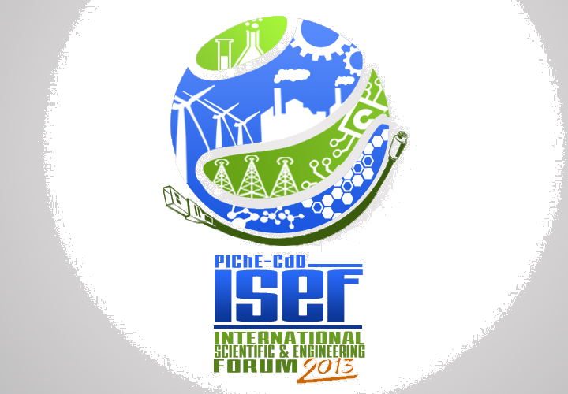
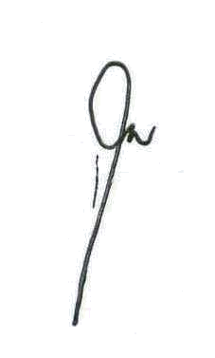
International Scientific & Engineering Forum
2013
“Fostering Research and Innovation in Engineering & Technology”
July 17 – 19, 2013
Pearlmont Hotel, Limketkai Drive, Cagayan de Oro City, Philippines

Host: Philippine Institute of Chemical Engineers – Cagayan de Oro Chapter

REGISTRATION FORM
(Please fill in the form completely and legibly.)

Type of Registration: | ___ Participant | ___Presenter

Prof./Dr./ Engr./ Mr./ Ms.
 | Family Name | First Name | MI

Position: |  | Institution/ Company:

Complete Address:

Email Address: |  | Mobile No.

If Presenter:
Title of Paper/s:

Registration Fees:

Industry | Academe/ Government | Local Students | Foreign Participant
Php 3500 | Php 3000 | Php 2500 | US$ 250
- The conference fee covers admittance to the conference proper, conference facilities, snacks, lunches (July 18&19), dinner (July 18), forum kit, certificates, Book of Abstracts, Proceeding in CD form but exclusive of accommodation.
- All participants including the presenters must PAY the appropriate registration fee.

Mode of Payment:
___ In Cash
___ Check or Money Order ( in favor of Philippine Institute of Chemical Engineers)
___ Interbranch deposit: Bank of Philippine Island - branch,
Account Name: Philippine Institute of Chemical Engineers
Account Number: 9333-0431-54
Participants who paid online must attach the scanned copy of the deposit slip with the participant’s name written legibly and send to badillagj@yahoo.com.ph and/or marylyntabasan@yahoo.com with the completed registration form.

- Send the completed Registration form (save using your name as filename and send as email attachment) to any of the following members of the Secretariat/ Technical committee on or before July 8, 2013:
redemptor96@gmail.com edwinrichard.ortiz@yahoo.com csnamocojr@yahoo.com badillagj@yahoo.com.ph marylyntabasan@yahoo.com
- The duly accomplished registration form will serve as your confirmation to this forum.

